COMPUTATIONAL THINKING (CT) APPLICATION REPORT
Project: Software Developer Management
1. DECOMPOSITION (Breaking down the problem)
- Goal: Split the monolithic program into independent modules.
- Result:
  - Data Models: Developer.java, Project.java
  - Business Logic: DeveloperManagement.java, ProjectManagement.java
  - Utilities (Tools): Acceptable.java, ReturnToMenuException.java
  - Controller: Main.java
2. PATTERN RECOGNITION
Identifying repetitive processing segments to create generalized, reusable solutions across the system:
- Validation Pattern: The requirement to prompt the user for non-empty strings, integers, or valid dates repeats across all Add/Update functions. I grouped these while(true) loops and try-catch blocks into reusable static methods: checkString(), checkInt(), and checkDate() inside the Acceptable class.
- CRUD Pattern (Create-Read-Update-Delete): Both Developer and Project entities require these fundamental operations. Recognizing this commonality, I created a Generic Interface Workable<T> to standardize method signatures and share this behavioral pattern across both management classes.
3. ABSTRACTION
- Data Modeling: Filtering out unnecessary real-world details to focus on core attributes relevant to the management system. For instance, a Developer is abstracted into essential fields like devID, fullName, programmingLanguages, and salary, ignoring irrelevant personal details.
- Functional Abstraction: Hiding complex underlying logic from the end-user. For example, when calling projManager.addFromConsole() from the Main class, all internal mechanisms (like duplicate ID checking or date parsing) are completely abstracted away within the business logic layer.

4. ALGORITHM DESIGN
Defining the step-by-step processing workflow for a main function to create an "Operation Workflow".
Example: Add a new Project (Operation Workflow)
- Input: projectID, devID, projectName, duration, startDate
- Step 1: Check if projectID already exists in the Project list.
  - If YES Display an error and prompt for re-entry.
- Step 2: Check if devID exists in the Developer list (Foreign Key constraint).
  - If NO Display the error: "Developer ID does not exist".
- Step 3: Check if duration is valid ($> 0$) and if startDate follows the dd/MM/yyyy format and is a future date.
  - If INVALID Display formatting errors.
- Step 4: If all inputs are valid Create a new Project object Add it to the list (projectList.add).
- Step 5: Display the success message: "Project added successfully".

5. CT DEPLOYMENT DIAGRAM
[Decomposition] (Result: DeveloperManagement, ProjectManagement, Acceptable classes)
⬇
[Pattern Recognition] (Result: Workable<T> Interface, Reusable Validation methods)
⬇
[Abstraction] (Result: Developer and Project classes with private attributes)
⬇
[Algorithm Design] (Result: Detailed implemented methods such as addFromConsole(), calculateTotalExperience()...)

Class Diagram
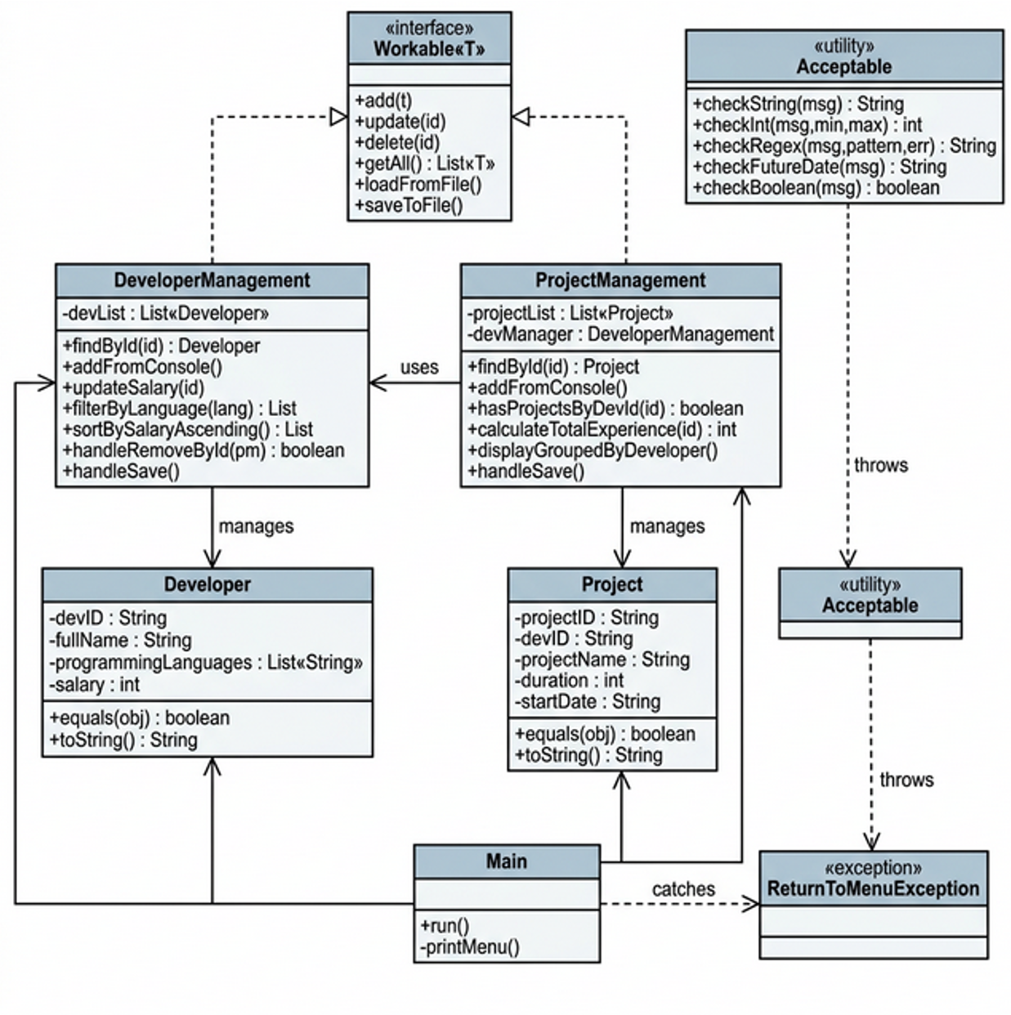

Flow-chart
